Abstract
This document explains step by step process of the BYOC prototype for the developers to understand the scope of the project

FuriX.ai

BYOC Prototype

CVSS Platform
Compliance Vulnerabilities SIEM SOAR
Sarath Chelika
support@furix.ai

BYOC prototype contents
- Asset Discovery
- Asset Inventory
- Asset Classification
- Scan Policies & Compliance Template Selection
- Scan Vulnerabilities Template selection
- Compliance and Vulnerability Scanning
- Normalization Correlation & De-duplication
- Compliance Framework Mapping
- Mapping to Vulnerability Databases
- Risk & Severity Scoring
- Reporting
- Remediation & Fix Guidance
- Validation & Re-scan
- Compliance & Vulnerability Dashboard
- Compliance and Vulnerabilities Flow Chart
- Compliance & Vulnerabilities Flow Diagram
- SIEM Data Collection
- Parsing Normalization & Enriching
- Correlation & Detection
- Core Detection Rule Library
- Data Schema & Field Standardization
- Alert Triage and Prioritization
- Incident Creation
- Automated Investigation
- Automated or Semi-Automated Response
- Case Management & Reporting
- Continuous learning & Tuning
- SIEM Dashboard
- SIEM-SOAR Bidirectional Integration
- SIEM & SOAR Flow Chart
- SIEM & SOAR Flow Diagram
- Infrastructure Architecture
- Device Administration
- Cloud Test Infrastructure
- Hardware requirements

BYOC Dashboard
- Dashboard must contain all the items listed in the BYOC prototype contents in steps 14 and 28.
Compliance and Vulnerabilities

Step 1: Asset Discovery
Goal: Identify all reachable systems.
Methods:
- Network scanning (ICMP, TCP/UDP)
- Active discovery (Nmap, scanners)
- Cloud assets (AWS/Azure/GCP)
- Containers
- AD / CMDB sync
- Output
- IP addresses
- Hostnames
- OS fingerprints
- Network devices

Step 2: Asset Inventory
Goal: Maintain a single source of truth.
Key attributes to capture during an asset inventory scan include:

Identification & Technical Details
- Asset Name/Hostname: Unique identifier for the machine on the network.
- IP Address & MAC Address: For network location and identification.
- Hardware Model/Manufacturer: The vendor and model number (e.g., Dell, Cisco).
- Serial Number/Service Tag: For warranty and lifecycle tracking.
- Operating System (OS) & Version: Detailed OS version and patch level.
- BIOS UUID/MAC Address: For unique device identification.
Operational & Functional Data
- Asset Role/Type: Categorization (e.g., Server, Workstation, IoT Device, Firewall).
- Physical Location/Address: Data center, rack, or office location.
- Active Protocols & Ports: Network communication protocols and open ports.
- Software/Firmware Installed: Applications and firmware versions.
- User Accounts: Last logged-in user, Local administrator and other accounts.
Management & Security Context
- Asset Criticality: Risk level (e.g., High, Medium, Low).
- Asset Owner: Department or individual responsible for the asset.
- Last Scan/Check-in Time: To measure data freshness.
- Compliance Status: Whether the device meets security policies
- Network/Subnet Information: The network segment where the asset resides.

Step 3: Asset Classification
Goal: Apply business context.
Classification Criteria:
- Criticality (High / Medium / Low)
- Data sensitivity (PHI, PII, Financial, Intellectual Property, biometric data, employee data)
- Compliance scope (CIS/NIST/ PCI-DSS/SOC/ Type 1 & II- In-scope)
Asset profiling:
- SNMP (v1/v2/v3): To gather detailed device data (routers, switches, printers).
- SSH: To access and profile Linux/Unix machines.
- WMI: To query Windows systems, often over DCOM/RPC.
- SMB (Server Message Block): Ports 139/445 are crucial for Windows file/printer sharing analysis.
- DNS-SD/mDNS/Bonjour: For detecting services in specific network environments

Requirements:

- Protocol Support: The scanner must support protocols like HTTPS, HTTP, FTP, and SIP for deeper service analysis.
- Authentication: For authenticated scans, valid credentials (e.g., SSH keys, domain credentials) are needed to access endpoints.

Why it matters:
- Drives scan depth
- Affects severity & remediation SLAs

Step 4: Scan Policies & Compliance Template Selection
Goal: Apply the right checks for the right asset.
- Scan profiles:
- Windows Server 2022
- Windows 10 & 11
- RHEL OS
- Cisco IOS

Step 5: Scan Vulnerabilities Template selection
Goal: Map product identity → known vulnerabilities.
- Scan profiles:
- Windows Server 2022
- Windows 10 & 11
- RHEL OS
- Cisco IOS

Step 6: Compliance & Vulnerability Scanning
Goal: Identify weaknesses.
Scan Types:
- Authenticated scans (preferred)
    - Linux credentials
    - Windows AD authentication
    - Local credentials for network devices
- Unauthenticated scans
Compliance
Controls (What to do): Organization wide posture
- CIS – 18 controls V8.1 (latest version)
- NIST CSF, NIST controls SP 800-53, NIST 800-171
- HIPAA Framework - Administrative, Physical, and technical safeguards
Benchmarks (How to do): Specific to Systems/Apps
- CIS Benchmarks
- HIPAA Benchmarks
Scanning Findings:
- Weak configurations
- Deprecated protocols
- Default credentials
- RBAC
- Identity Access Management
- Permission creep
- Excessive privileges
Vulnerability

Scan profiles primary sources

- CVE (Common Vulnerabilities and Exposures)
- NVD (NIST database)
- Vendor advisories (Red Hat, Microsoft, etc.)
- Exploit databases (optional enrichment)

Templates Include:
- Vulnerability checks (CVEs)
- Configuration compliance checks
- Patch level validation
Scanning findings:
- CVE detection (missing patches, vulnerable services)
- Weak services (open ports, weak SSL)
- Outdated packages
- Misconfigurations

Step 7: Normalization, Correlation & De-duplication
Goal: Standardize raw scanner output into actionable issues
Actions
- Deduplicate findings
- Normalize CVE IDs
- Group by asset, control, OS
- Output
- Clean findings dataset
- Correlate vulnerabilities with:
  - Asset criticality
  - Exposure (internet-facing vs internal)
  - Known exploits (KEV list)

Step 8: Compliance Framework Mapping (NIST / HIPAA / CIS)
Goal: Translate technical findings into compliance impact.
Mapping Examples:
Check (Control ID) | What You Check | NIST 800-53 | PCI-DSS | CIS Benchmark | SOC Type I & II
CFG-ENCRYPT-AT-REST | Disk encryption enabled | SC-12, SC-28 | TBD | CIS 2.3 | TBD
CFG-PASSWORD-POLICY | Password complexity | IA-5 | TBD | CIS 1.1 | TBD
CFG-AUDIT-LOGGING | OS audit logging enabled | AU-2, AU-12 | TBD | CIS 4.1 | TBD
CFG-PATCHING | OS patches current | SI-2 | TBD | CIS 7.1 | TBD
CFG-ADMIN-USERS | Least privilege | AC-2, AC-6 | TBD | CIS 1.2 | TBD

Create a Framework Mapping Engine
Goal: Automatically translate scan results into compliance status.
Flow
Raw Scan Finding
↓
Normalized Control ID
↓
Framework Mapping Table
↓
Framework Control Status (Pass/Fail/Partial)
↓
Generate a report with findings, status, resolution
Result
- Compliance gaps by framework
- Audit-ready evidence

Step 9: Mapping to Vulnerability Databases
Goal: Create a stable identifier to query vuln databases.
- Use CPE (Common Platform Enumeration):
Example: cpe:2.3:a:apache:http_server:2.4.49:*:*:*:*:*:*:*

How:
- Vendor + product + version → CPE
- Maintain a CPE dictionary (aliases, package names → canonical CPE)
- Handle distro backports (e.g., RHEL patches w/ older versions)
Pitfall to avoid: Version ≠ vulnerability (vendors backport fixes without bumping versions)
Create a Vulnerability Mapping Engine
CPE
↓
NVD / Vendor Feeds
↓
List of CVEs
Output example
{
"cpe": "cpe:2.3:a:apache:http_server:2.4.49:*:*:*:*:*:*:*",
"cves": ["CVE-2021-41773", "CVE-2021-42013"]
}
↓
Generate a report with findings, status, resolution

Product design:
- Cache CVE feeds locally
- Daily Sync Jobs
- Delta updates for speed

Validate Exploitability (False Positive Reduction)
Checks:
- Is the vulnerable module enabled?
- Is the vulnerable feature exposed externally?
- Is the patch already backported?
- Is the vulnerable path reachable?

Example: Apache vuln only exploitable if mod_cgi enabled → check config

Step 10: Risk & Severity Scoring
Goal: Prioritize what to fix first.
CVSS (Vulnerability Severity Scoring System)
Base Score: 0.0 – 10.0
Factors:
- Attack vector
- Privileges required
- Impact (CIA)
- CVSS score
- Asset criticality (prod DB > intern laptop)
- Exploit availability
- Internet exposure
- Compliance impact (CIS/HIPAA/NIST control violation)
Severity Ratings:
CVSS Score
      - Severity: 9.0 – 10.0
      - Critical: 7.0 – 8.9
      - High: 4.0 – 6.9
      - Medium: 1 - 3.9
      - Low: 0 – 0.9
Risk Calculation:
- Risk = CVSS × Asset Criticality × Data Sensitivity

Step 11: Reporting & Audit Evidence
Goal: Communicate results to stakeholders.
Report Types
- Executive summary (risk posture)
- Technical remediation report
- Compliance gap report (NIST / SCO Type I & II/ CIS / PCI)
- Trend analysis
- Formats
- PDF
- CSV

Step 12: Remediation & Fix Guidance
Goal: Reduce risk.
Fix Guidance Includes
Patch instructions
- Configuration hardening steps
- Step-by-step remediation
- Remediation workflows
- OS-specific commands
- Compensating controls
- Vendor references
- Ownership
- Assigned to system owner
- Patch links
- Risk explanation for managers
- Auto-ticket creation (Jira/ServiceNow)
SLA based on severity:
Severity SLA
- Critical 7 days
- High 30 days
- Medium 90 days
- Low Best effort

Step 13: Validation & Re-Scan
Goal: Prove the fix worked.
Flow:
- Trigger re-scan
- Confirm vulnerability is closed
- Update compliance score
- Close ticket automatically

Step 14: Dashboard
- Compliance/Vulnerabilities/SIEM/SOAR/Metrics/GRC integration
1. Essential Dashboard Items
- The dashboard should provide a high-level "vital signs" view of the organization’s security and legal health.
- Compliance Health Score: A single aggregate metric or "scorecard" showing overall adherence to regulatory frameworks (e.g., SOX, PCI, HIPAA).
- Vulnerability Severity Breakdown: A visual distribution (e.g., pie or bar chart) of open vulnerabilities categorized as Critical, High, Medium, or Low.
- Mean Time to Resolution (MTTR): The average time taken to remediate vulnerabilities or resolve compliance issues, critical for tracking SLA discipline.
- Risk Heatmap: A visualization mapping risk exposure by business unit, geography, or asset type to highlight high-priority areas.
- Audit Readiness Status: A tracker for control testing completion rates and the status of evidence collection for pending audits.
- Training Completion Rates: Real-time percentage of employees who have finished mandatory compliance and security training.
- Policy Acknowledgment: Monitoring the rate at which staff have electronically signed and acknowledged updated company policies.

2. Primary Menu Structure
- The menu should follow a logical lifecycle—Discovery, Assessment, Remediation, and Reporting—to ensure ease of use for different stakeholders.
- Asset Management
- Inventory: Unified view of all hardware, software, cloud assets, and endpoints.
- Discovery: Tools for continuous scanning to find "Shadow IT" or new network additions.
- Vulnerability Center
- Scans: Schedule, run, and view results of automated security scans.
- Prioritization: List of CVEs (Common Vulnerabilities and Exposures) ranked by business risk and exploitability.
- Remediation Workflows: Active tickets for patching, configuration changes, or risk acceptance.
- Compliance & Governance
- Frameworks & Controls: Library of specific regulations (e.g., Delaware state-specific policies) and internal controls.
- Policy Library: Central repository for all active and archived corporate policies.
- Evidence Locker: Secure repository for audit work-papers and control test results.
- Reports & Analytics
- Executive Summaries: High-level PDF/Excel exports for board-level reporting.
- Audit Trails: Detailed logs of user actions and system changes for transparency.
- Trend Analysis: Historical data showing risk reduction over time.

Step 15: Visual Flow Chart
A[Asset Discovery] B[Asset Inventory]
B C[Asset Classification]
C D[Select Scan Templates]
D D1[Windows Server 2022, Windows 11 & 10]
D D2[RHEL OS]
D D3[Cisco IOS]
D1 E[Vulnerability & Compliance Scan]
D2 E[Vulnerability & Compliance Scan]
D3 E[Vulnerability & Compliance Scan]
E F[Normalize Findings]
F G[Map to Frameworks]
G G1[NIST Controls]
G G2[HIPAA Rules]
G G3[CIS Controls]
G1 H[Severity & CVSS Scoring]
G2 H[Severity & CVSS Scoring]
G3 H[Severity & CVSS Scoring]
H I[Risk Prioritization]
I J[Generate Reports]
J K[Remediation Guidance]
K L[Fix]
L M[Validate & rescan)
L E

Note: The loop back to scanning supports continuous compliance.

Step 16: Flow diagram
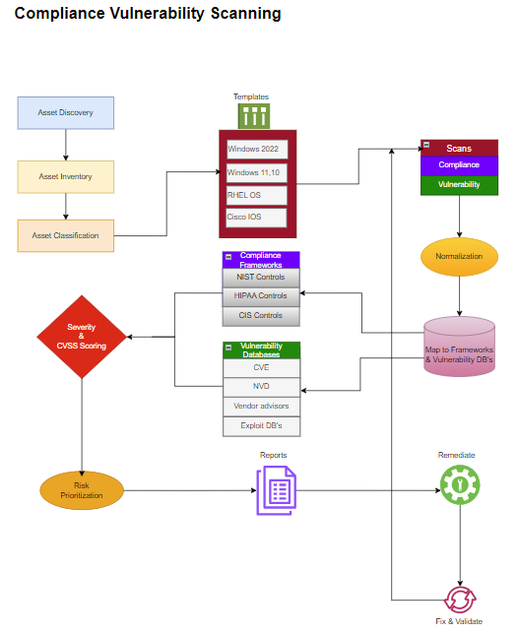

SIEM and SOAR

Step 1: Data Collection (Telemetry Ingestion)
Goal: Get security data/logs from everywhere

Sources
- Endpoints (Windows, Linux, macOS)
- Network devices (firewalls, routers, switches)
- Cloud platforms (AWS, Azure, GCP)
- SaaS apps (M365, Google Workspace)
- Security tools (EDR, IDS/IPS, WAF)
- Applications & databases
- Hypervisor, VM’s & Storage
- Identity & Access
- Endpoint (EDR)
- Email Security
- Web Application
- Database Activity
- DHCP & DNS
- Vulnerability Scanners

How SIEM works:
- Agents, Syslog, APIs, webhooks
- Normalizes different formats into a common schema

Step 2: Parsing, Normalization & Enrichment
Goal: Make raw logs usable for detection

What happens
- Parse fields (IP, user, hostname, process)
- Normalize common fields (src_ip, dst_ip, user)
- Enrich with:
- GeoIP
- Threat intelligence
- Asset criticality
- User identity (AD/Entra ID)
- Vulnerability context (CVEs)

Step 3: Data Schema & Field Standardization
Consistent schema is what makes correlation across sources possible. Every event in Elasticsearch must conform to ECS (Elastic Common Schema).
- Mandatory fields for every event: timestamp (UTC, ISO 8601), event.dataset, event.module, host.name, host.ip, log.level
- Network events must have source.ip, source.port, destination.ip, destination.port, network.protocol, network.direction
- Process events must have: process.name, process.pid, process.parent.name, process.executable, user.name, host.name
- Authentication events must have: user.name, user.domain, event.outcome (success/failure), source.ip, event.action
- Custom fields: use labels. * namespace for organization-specific enrichment (labels.asset_criticality, labels.data_classification)

Step 4: Correlation & Detection (SIEM Brain)
Goal: Turn events into security alerts

Detection methods
- Rule-based correlation
- “5 failed logins + success from new country = suspicious”
- Behavioral analytics (UEBA)
- Threat-intel matching (known bad IPs, hashes)
- Baselines & anomaly detection
- MITRE ATT&CK mapping
- Patterns
- ML-based Anomaly detection
- Penetration test automation
- Failed logs

Output
- Alerts (with severity, confidence, affected assets)

Step 5: Core Detection Rule Library
Build this minimum rule set before declaring the SIEM production ready. Each rule should be tested against both benign and malicious samples before activation.

Rule Name | Detection Logic Summary | MITRE ATT&CK
Brute Force / Password Spray | >=10 auth failures across >=3 accounts from same source IP in 10 minutes | T1110 — Brute Force
Impossible Travel | Same user authenticates from two geographic locations physically impossible to travel between in time | T1078 — Valid Accounts
New Admin Account Created | New account created AND added to privileged group within 24 hours, especially after-hours | T1136 — Create Account
Scheduled Task / Cron Creation | New scheduled task or cron job created by a non-admin user or on a non-standard system | T1053 — Scheduled Task
PowerShell Encoded Command | PowerShell process launched with -EncodedCommand or -Enc flags — common malware obfuscation | T1059.001 — PowerShell
LSASS Memory Access | Non-system process opening LSASS.exe with PROCESS_VM_READ — credential dumping attempt | T1003.001 — LSASS Memory
Lateral Movement via PsExec/WMI | Remote process execution via PsExec, WMI, or SMB from a workstation (not server) to another host | T1021 — Remote Services
DNS Tunneling | Single DNS query longer than 100 chars, or >1000 DNS queries/min to same domain, high entropy domains | T1071.004 — DNS
Data Exfil — Large Upload | Outbound data transfer >1 GB to a non-corporate IP in a single session, especially to cloud storage | T1048 — Exfiltration
C2 Beaconing | Regular interval outbound connections (jitter <10%) to same external IP over >1 hour on non-standard ports | T1071 — App Layer Protocol
Cloud IAM Privilege Escalation | IAM policy attached that allows iam:PassRole or sts:AssumeRole with * resource | T1078.004 — Cloud Accounts
Ransomware Indicators | Mass file rename/extension change (>100 files/min) + shadow copy deletion + desktop.ini modification | T1486 — Data Encryption

Step 6: Alert Triage & Prioritization
Goal: Decide what matters NOW

What SIEM provides
- Define the alert quality KPI
- Implement a tuning workflow
- Severity scoring
- Asset criticality weighting
- Confidence scores
- Duplicate alert suppression
- Incident grouping (related alerts merged)
- Review cadence

Step 7: Incident Creation (Handoff from SIEM → SOAR)
Goal: Turn alerts into actionable incidents

What happens
- High-confidence alerts become “Incidents”
- Context is attached:
- Timeline
- Impacted users/devices
- Related alerts
- Threat intelligence
- Incident sent to SOAR platform

Step 8: Automated Investigation (SOAR Playbooks)
Goal: Enrich incidents automatically

Typical SOAR actions
- Query EDR: Is malware present?
- Checking IP reputation
- Pull user login history
- Check recent vulnerability scans
- Identify lateral movement
- Attach MITRE technique mapping

Output
- Full investigation context in minutes (instead of hours)

Step 9: Automated or Semi-Automated Response
Goal: Contain the threat FAST

Automated actions
- Disable compromised user
- Quarantine endpoint
- Block IP/domain on firewall
- Revoke API keys
- Reset credentials
- Kill malicious process

Human-in-the-loop
- Approvals for destructive actions
- Manual override
- Step-by-step guided response

Step 10: Case Management & Reporting
Goal: Close the loop and satisfy compliance

Output
- Incident timeline
- Root cause analysis
- Impact summary
- Remediation steps
- Compliance mapping (NIST, CIS, ISO 27001, HIPAA)
- SLA metrics (MTTD, MTTR)

Step 11: Continuous Learning & Tuning
Goal: Get smarter over time

Feedback loop
- False positives → tune detection rules
- New attack patterns → add new playbooks
- Customer behavior → adjust baselines
- AI/ML model retraining

Step 12: SIEM Dashboard
SOC Dashboard: The primary dashboard is what Tier 1 analysts see all day. It must convey maximum signal with minimum cognitive load. Every element must be actionable — no vanity metrics.

- Real-time alert queue: list of open alerts sorted by risk score, with age, assigned analyst, and status indicator; filter by severity, source, technique
- Security posture score: rolling 24-hour and 7-day risk score trend based on open alert severity distribution and SLA breach count
- MTTD / MTTR widgets: mean time to detect and mean time to respond, current day vs. 30-day rolling average, broken down by alert type
- Active threat map: geographic visualization of active threat indicators — inbound attacks, authentication anomalies, outbound suspicious connections
- Top assets under attack: ranked list of hosts with the highest open alert count and aggregate risk score; click to pivot to asset investigation view
- Alert volume trend: 72-hour sparklines per log source showing volume anomalies — sudden spikes or drops both indicate problems

Threat Hunting Workspace: The threat hunting interface is for Tier 2/3 analysts running proactive investigations without a specific alert trigger.

- Query builder: visual and raw KQL/Lucene query interface with field autocomplete, saved query library, and query history
- Timeline view: visualize multiple event streams on a shared time axis — correlate firewall, endpoint, and identity events visually
- Graph/link analysis: entity-relationship visualization showing connections between IPs, users, hosts, and processes derived from log data
- IOC pivot: enter any IP, domain, hash, or username and immediately see all events involving that entity across all time
- Hunt library: saved, version-controlled hunt hypotheses with execution history, findings, and MITRE technique tags — knowledge base for the team
- Notebook integration: Jupyter-style analysis notebooks for complex multi-step investigations using Elasticsearch Python client

Case Management: Every alert that requires human investigation must be promoted to a Case. Cases track the full lifecycle of an investigation from detection to closure.

- Case fields: title, severity, status (New/In Progress/Pending/Closed), assigned analyst, escalation tier, MITRE tactics, affected assets, affected users
- Evidence attachment: attach raw log queries, screenshots, external threat intel reports, and SOAR playbook execution records to the case
- Timeline reconstruction: auto-populate a chronological event timeline from all logs related to the case's affected assets and users in the investigation window
- Collaboration: comments with @mentions, status change history, time-logged entries for SLA tracking, escalation workflow
- Reporting: one-click incident report generation from case data; executive summary, technical narrative, IOC list, remediation actions taken.

Step 13: SIEM-SOAR Bidirectional Integration
The connection between SIEM and SOAR is the most important integration in the platform. It must be reliable, fast, and carry rich context.
- Alert forwarding: SIEM sends high-fidelity alerts to SOAR via webhook (HTTPS POST) within 10 seconds of alert creation
- Alert payload: include full raw event data, ECS-normalized fields, SIEM rule metadata, MITRE tags, asset context, and user context — not just the alert title
- Case sync: when SOAR creates or updates a case, sync status back to the SIEM case management system to maintain single pane of glass
- Playbook results: SOAR posts execution results (actions taken, IOCs found, containment status) back to the SIEM alert as enrichment data
- Bi-directional IOC sharing: analyst-confirmed IOCs in SIEM investigations automatically feed into SOAR playbook context for future incidents

Step 14: SIEM + SOAR Work simple flow chart
Logs/Telemetry
↓
SIEM
(Normalize → Correlate → Detect)
↓
Alerts → Incidents
↓
SOAR
(Investigate → Enrich → Respond)
↓
Containment + Reports + Learning

Step 15: Flow Diagram
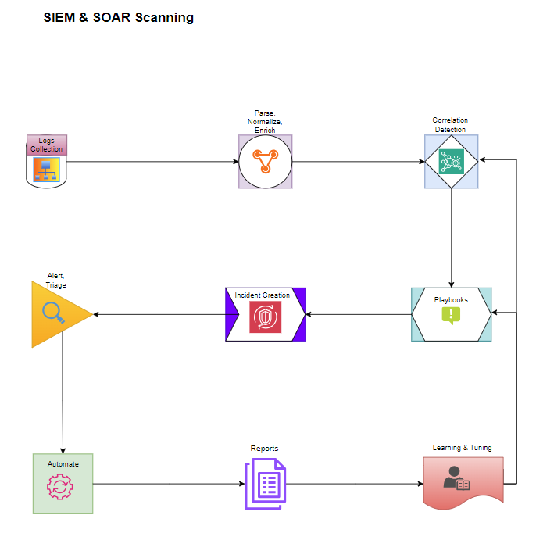

Test Infrastructure Architecture:
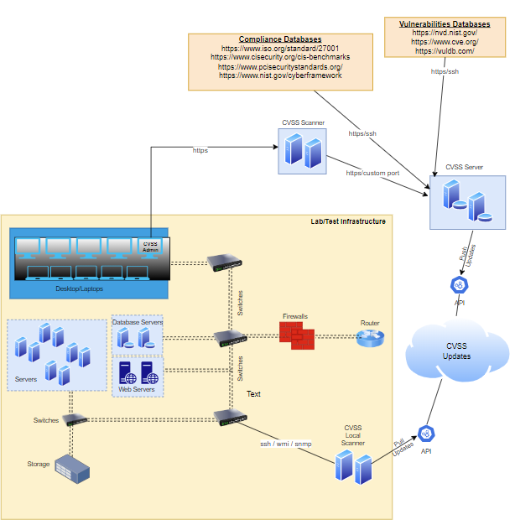

CVSS Design at High Level

- CVSS is a Saas application which can run the scans over the internet securely.
- CVSS application is an executable file that can be installed on a VM server or desktop/laptop at the client site as an alternate solution.
- A secured tunnel (IPsec) is going to be created between the CVSS application and CVSS server.
- CVSS applications require access to all the assets over SSH/WMI/SNMP to scan and manage.
- CVSS application is going to pull/receive the updates from CVSS server hosted on the cloud.
- For the prototype CVSS is going to be an agent-based platform.

Device Administration:
Set up:
- Device Name
- Description
- Device IP address, Subnet Mask, Default Gateway, DNS servers, NTP Servers
- Proxy servers

Scanner management:
  - Enable/Disable Scanners
  - Sensor status
  - Update plugins

Users:
  - Administrator
  - Auditor
  - Executive laptop
  - Vulnerability Analyst
  - Security Analyst
  - Custom role

Credentials:
    - Linux credentials
    - Windows AD authentication
    - Local credentials for network devices
    - SNMP credentials

System Maintenance:
  - System updates
  - Manage backups
  - Monitor system resources
  - Licensing
  - Plugin feeds

* Note: Methods, resources and Network devices in RED are in the scope of the prototype *

Cloud test infrastructure

Total number of devices 10 - 12:
1 x Windows Server (Includes Windows AD Domain services, AD Certificate services, GP, DNS, DHCP, File and Storage, Print, Hyper-V, WSUS, NPAS)

1 x Windows server (Includes IIS, SQL server, PowerShell, RSAT tools, Windows Defender, Remote Access, Remote Desktop services, Disk encryption, Clustering)

1 x RHEL server (Database – MySQL or PostgreSQL, Nginx or Apache web server, FTP server, AD Integration, LDAP, Identity Management, LVM & XFS storage management)

1 x RHEL server (Ansible for automation, Cockpit web console, Storage management, OpenSCAP Crypto policies, NBDE server, metrics role PCP)

1 x Windows desktop computer (Copilot, Microsoft 365/Office, Teams, Bitwarden, Zoom/Slack, Sngait, Microsfot Edge, Clipchamp, Visual Studio, VMware workstation, Power BI, Virtual desktopns, RDP, Windows Hello, Windows Autopilot, Microsoft Intune & Endpoint manager, Defender)

1 x Ubuntu desktop (LibreOffice, OnlyOffice, Thunderbird, Transmission(torrents), Rhythmbox, Shotwell, Chrome, Firefox, Joplin SimpleNote, GNOME Files, Archive manager, ufw(built-in-firewall), automatic security updates, VirtualBox, Nextcloud, Calire, CodePyCharmAndriod Studio, GitDockerSSH, MySQL Workbench, wireshark)

1 x Cisco Catalyst 8000V Edge Software

1 x Cisco CSR 1000V

1 x Palo Alto Networks VM-Series

1 x F5 BIG-IP Virtual Edition (VE)

Hardware requirements
Windows Server 2022 minimum VM Hardware Requirements
- CPU: 1.4 GHz 64-bit processor (x64 architecture), supporting NX/DEP, CMPXCHG16b, LAHF/SAHF, and PrefetchW.
- RAM: 512 MB (minimum for Server Core), 2 GB (minimum for Server with Desktop Experience). For usable performance, 4 GB or more is highly recommended.
- Storage: 32 GB minimum, with 64 GB+ recommended for Desktop Experience installations.
- Networking: Gigabit Ethernet adapter (1 Gbps) recommended for network throughput.
- Firmware: UEFI 2.3.1c-based system with Secure Boot enabled (required for TPM support).
- Security: Virtual Trusted Platform Module (vTPM) 2.0 (necessary for some security

RHEL 8/9 Virtual Machine Minimum Requirements
For a standard installation (using 64-bit x86-64 architecture), these are the minimums required by Red Hat:
- CPU: 2 vCPUs (64-bit x86-64-v2 microarchitecture required for RHEL 9).
- RAM: 1.5 GiB minimum for local installation; 4 GB or more is highly recommended for general use.
- Disk Space: 10 GiB (minimum), but 20 GB of unallocated disk space is recommended for installation.
- Network: 1 Network Interface Card (NIC) with 1 Gbps bandwidth

Windows 11 minimum hardware requirements
- CPU: 2+ vCPUs (1 GHz+)
- RAM: 4GB+ RAM, 64GB
- Disk: 128GB+ SSD
- Firmware: UEFI/Secure Boot enabled
- Security: virtual TPM 2.0 (vTPM)

Ubuntu (24.04 LTS) minimum requirements
- CPU: 64-bit 2 GHz dual-core processor
- RAM: 4-8 GB RAM
- Disk: 25 GB of free disk space

